Homework 3

Minyue Liu ml4368

Problem 1

Problem 2

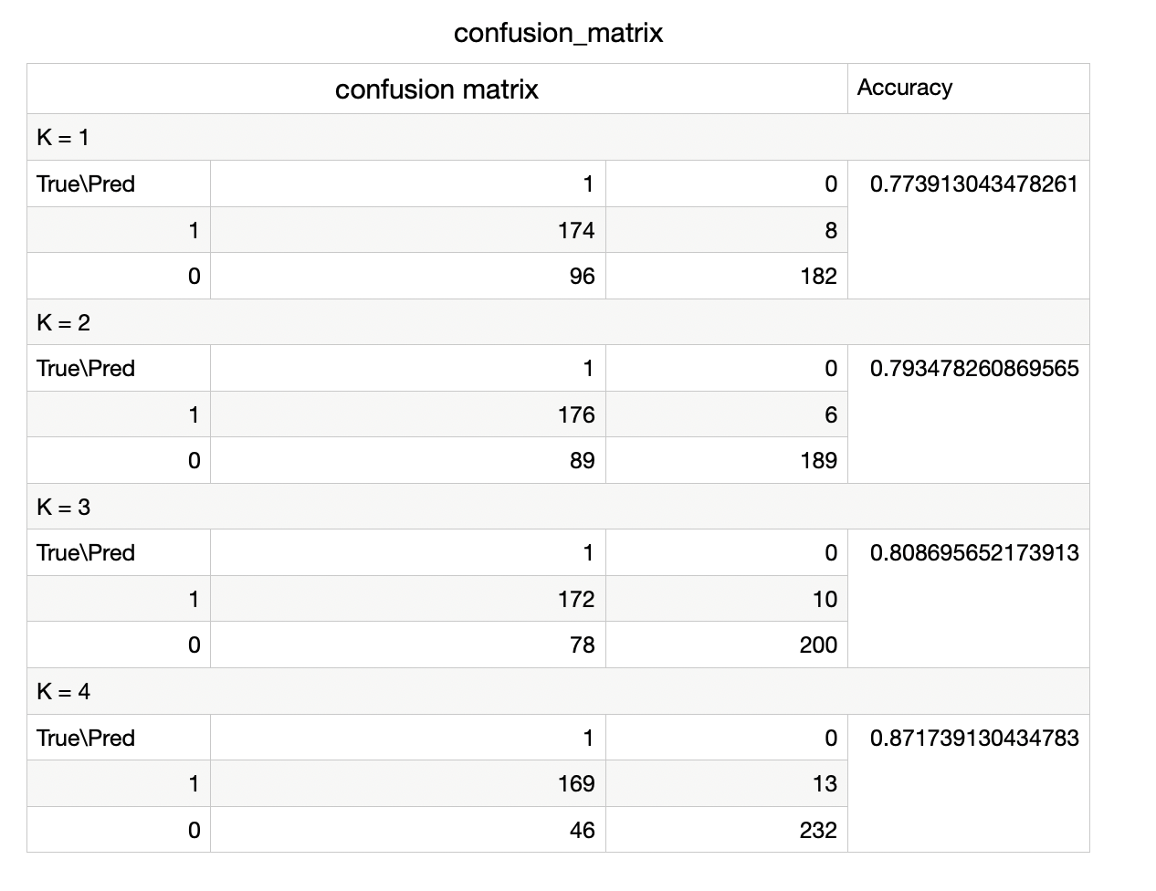

Problem 3

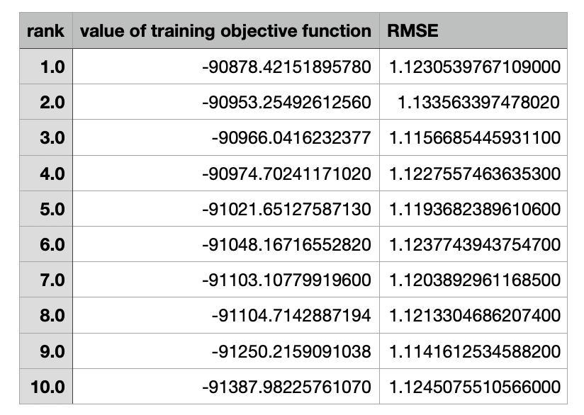

s

